January 2026

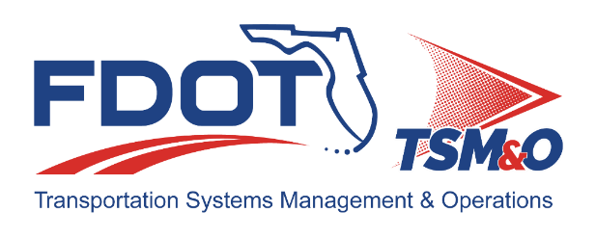
Florida ITS Architecture Support and Maintenance Project
D1 RITSA Update Report
(ARC-IT Version 9.3)

Document Version Control
Author / Action | Submittal Date | Version No.
David Binkley / Draft Document Development | January 15, 2025 | A93-2026
Cliff Heise / QA/QC Review | January 16, 2025 | A93-2026

Table of Contents
1.0 Introduction 4
2.0 Description of Changes 4

List of Tables
Table 1. Architecture Updates 4
Table 2. Architecture Maintenance Log (D1 RITSA) 6

Introduction
This Architecture Update Report for the Florida District 1 Regional Intelligent Transportation Systems (ITS) Architecture (D1 RITSA) identifies the revisions incorporated into the architecture. Revisions made to the D1 RITSA are documented in this report to support Stakeholder input received through Architecture Change Requests as part of the Florida ITS Architecture Support and Maintenance Project.
The Florida ITS Architecture Support and Maintenance Project included the initial major update of the Statewide Regional ITS Architecture and seven Regional ITS Architectures. Following the major update phase, periodic updates are executed to maintain the architecture content. The FDOT Architecture Team coordinates with the FDOT Project Manager or designee and each applicable District Transportation Systems Management and Operations (TSM&O) Program Engineer or designee for the RITSAs

Description of Changes
One maintenance log item was addressed in the update. Table 1 provides descriptions for each change request that was implemented in the architecture update. A log reference number is provided for each change to relate it to the Architecture Maintenance Log that is provided in Appendix A. Each architecture change that is received is added to the maintenance log for tracking and disposition.
Information about stakeholders, elements, and services is provided to summarize the changes. Some architecture components such as interfaces, roles and responsibilities, functional requirements and standards are numerous and can be reviewed on the architecture website or in the Regional Architecture Development for Intelligent Transportation (RAD-IT) software tool to explore the details of each project.
Table 1. Architecture Updates
Change | Log Ref # | Actions Taken / Changes Implemented
Project Status Change - City of Sarasota Smart School Zone Project | 214 | Changed the status of the project from Planned to Existing. This change was also made to the  - Inventory elements,  - Service package,  - Speed Zone Warning and Control (City of Sarasota Smart School Zones).  - Information flows,  - Roles and Responsibilities, and  - Functional Requirements.

Appendix A: Architecture Maintenance Log (D1 RITSA)
The maintenance log in Table 2 provides the D1 RITSA maintenance items considerations for the update.
Table 2. Architecture Maintenance Log (D1 RITSA)
# | Date | Source | Contact | Change | Disposition | Recommend Maintenance | Incorporated
214 | 12/15/2025 | Change Request Form: FDOT District 1 | Dennis Hughes / City of Sarasota | Project Status Change - City of Sarasota Smart School Zone Project. The City of Sarasota Smart School Zone Project has been fully deployed and is now operational. The project status should be changed from “Planned” to “Existing”. | D1 project status to be changed; will evaluate status changes for elements, flows, etc in the project. | Yes | Yes

