September 2026

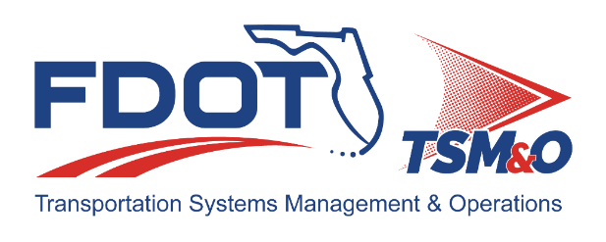
Florida ITS Architecture Support and Maintenance Project
D3 RITSA Update Report
(ARC-IT Version 9.4)

Document Version Control
Author / Action | Submittal Date | Version No.
Faranak Ashkiani / Draft Document Development | September 10, 2026 | A94-2026
David Binkley / QA/QC Review | September 10, 2026 | A94-2026

Table of Contents
1.0 Introduction 4
2.0 Description of Changes 4

List of Tables
Table 1. Architecture Updates 4
Table 2. Architecture Maintenance Log (D3 RITSA) 7

Introduction
This Architecture Update Report for the Florida District 3 Regional Intelligent Transportation Systems (ITS) Architecture (D3 RITSA) identifies the revisions incorporated into the architecture. Revisions made to the D3 RITSA are documented in this report to support Stakeholder input received through Architecture Change Requests as part of the Florida ITS Architecture Support and Maintenance Project.
The Florida ITS Architecture Support and Maintenance Project included the initial major update of the Statewide Regional ITS Architecture and seven Regional ITS Architectures. Following the major update phase, periodic updates are executed to maintain the architecture content. The FDOT Architecture Team coordinates with the FDOT Project Manager or designee and each applicable District Transportation Systems Management and Operations (TSM&O) Program Engineer or designee for the RITSAs.

Description of Changes
This update incorporates one maintenance log item. Table 1 provides descriptions for each change request that was implemented in this architecture update. A log reference number is provided for each change to relate it to the Architecture Maintenance Log that is provided in Appendix A. Each architecture change that is received is added to the maintenance log for tracking and disposition.
Information about stakeholders, elements, and services is provided to summarize the changes. Some architecture components such as interfaces, roles and responsibilities, functional requirements and standards are numerous and can be reviewed on the architecture website or in the Regional Architecture Development for Intelligent Transportation (RAD-IT) software tool to explore the details of each project.
Table 1. Architecture Updates
Change | Log Ref # | Actions Taken / Changes Implemented
Inventory element name change | 219 | Changed the name of the Tallahassee International Airport to the Bobby Bowden -Tallahassee International Airport. This change was reflected in the following places:  - Stakeholder description for the Airport Authorities  - Inventory element: Tallahassee International Airport now called the “Bobby Bowden -Tallahassee International Airport”  - Service packages diagrams,  - DM01 - ITS Data Warehouse (Apalachee RPC (2 of 2))  - DM01 - ITS Data Warehouse (Emerald Coast Regional Council (2 of 2))  - DM01 - ITS Data Warehouse (Local Transportation Data Archive Management System (3 of 3))  - PT14 - Multi-modal Coordination (Transit and Multimodal Centers (1 of 2))  - Information flow diagrams

Appendix A: Architecture Maintenance Log (D3 RITSA)
The maintenance log in Table 2 provides the D3 RITSA maintenance items considerations for the update.
Table 2. Architecture Maintenance Log (D3 RITSA)
# | Date | Source | Contact | Change | Disposition | Recommend Maintenance | Incorporated
219 | 7/21/2026 | Change Request Form: FDOT District 3 | James Landini / FDOT CO | Tallahassee International Airport renamed to Bobby Bowden -Tallahassee International Airport per legislative Bill 628. | Update Stakeholder, Inventory, and associated flow diagrams. | Yes | Yes

